MAD LAB CYCLE 2

1.Create 2 Activities from 1st Activity on click move to 2nd activity (Using Intent)

activity-main.xml
<?xml version="1.0" encoding="utf-8"?>
<LinearLayout
android:id="@+id/p1"
android:layout_width="match_parent"
android:layout_height="match_parent"
android:orientation="vertical"
android:gravity="center"
xmlns:android="http://schemas.android.com/apk/res/android">
<Button
android:layout_width="wrap_content"
android:layout_height="wrap_content"
android:gravity="center"
android:onClick="click"
android:text="Click"/>
</LinearLayout>
MainActivity.java
package com.example.sjcet.twoactivity;
import android.support.v7.app.AppCompatActivity;
import android.os.Bundle;
import android.view.View;
import android.content.Intent;
import android.widget.Button;
public class MainActivity extends AppCompatActivity {
@Override
protected void onCreate(Bundle savedInstanceState) {
super.onCreate(savedInstanceState);
setContentView(R.layout.activity_main);
}
public void click(View view) {
Opennewactivity();
}
public void Opennewactivity()
{
Intent intent=new Intent(this,Main2Activity.class);
startActivity(intent);
}
}
activity-main2.xml
<?xml version="1.0" encoding="utf-8"?>
<android.support.constraint.ConstraintLayout
xmlns:android="http://schemas.android.com/apk/res/android"
xmlns:app="http://schemas.android.com/apk/res-auto"
xmlns:tools="http://schemas.android.com/tools"
android:layout_width="match_parent"
android:layout_height="match_parent"
android:layout_gravity="center"
tools:context=".Main2Activity">
<TextView
android:layout_width="wrap_content"
android:layout_height="wrap_content"
android:gravity="center"
android:text="Activity 2"
tools:layout_editor_absoluteX="164dp"
tools:layout_editor_absoluteY="237dp" />
</android.support.constraint.ConstraintLayout>
Main2Activity.java
package com.example.sjcet.twoactivity;
import android.support.v7.app.AppCompatActivity;
import android.os.Bundle;
public class Main2Activity extends AppCompatActivity {
@Override
protected void onCreate(Bundle savedInstanceState) {
super.onCreate(savedInstanceState);
setContentView(R.layout.activity_main2);
}
}
OUTPUT
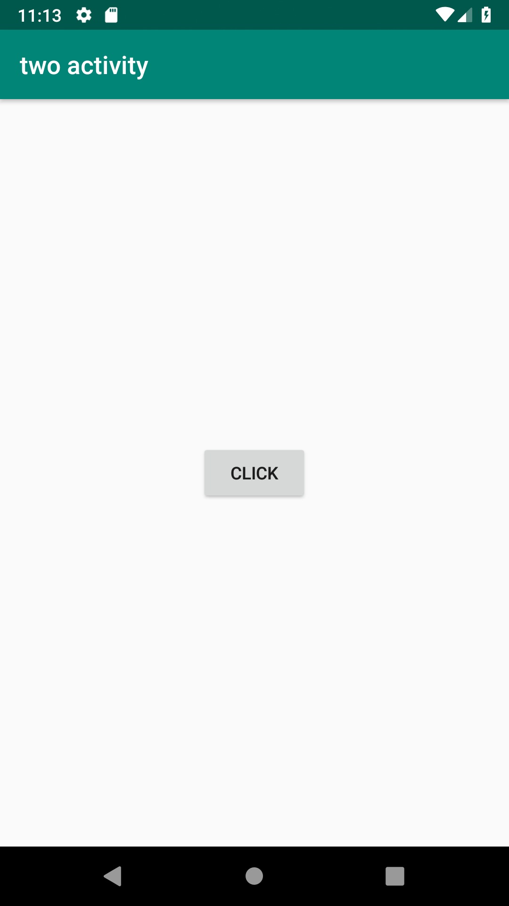

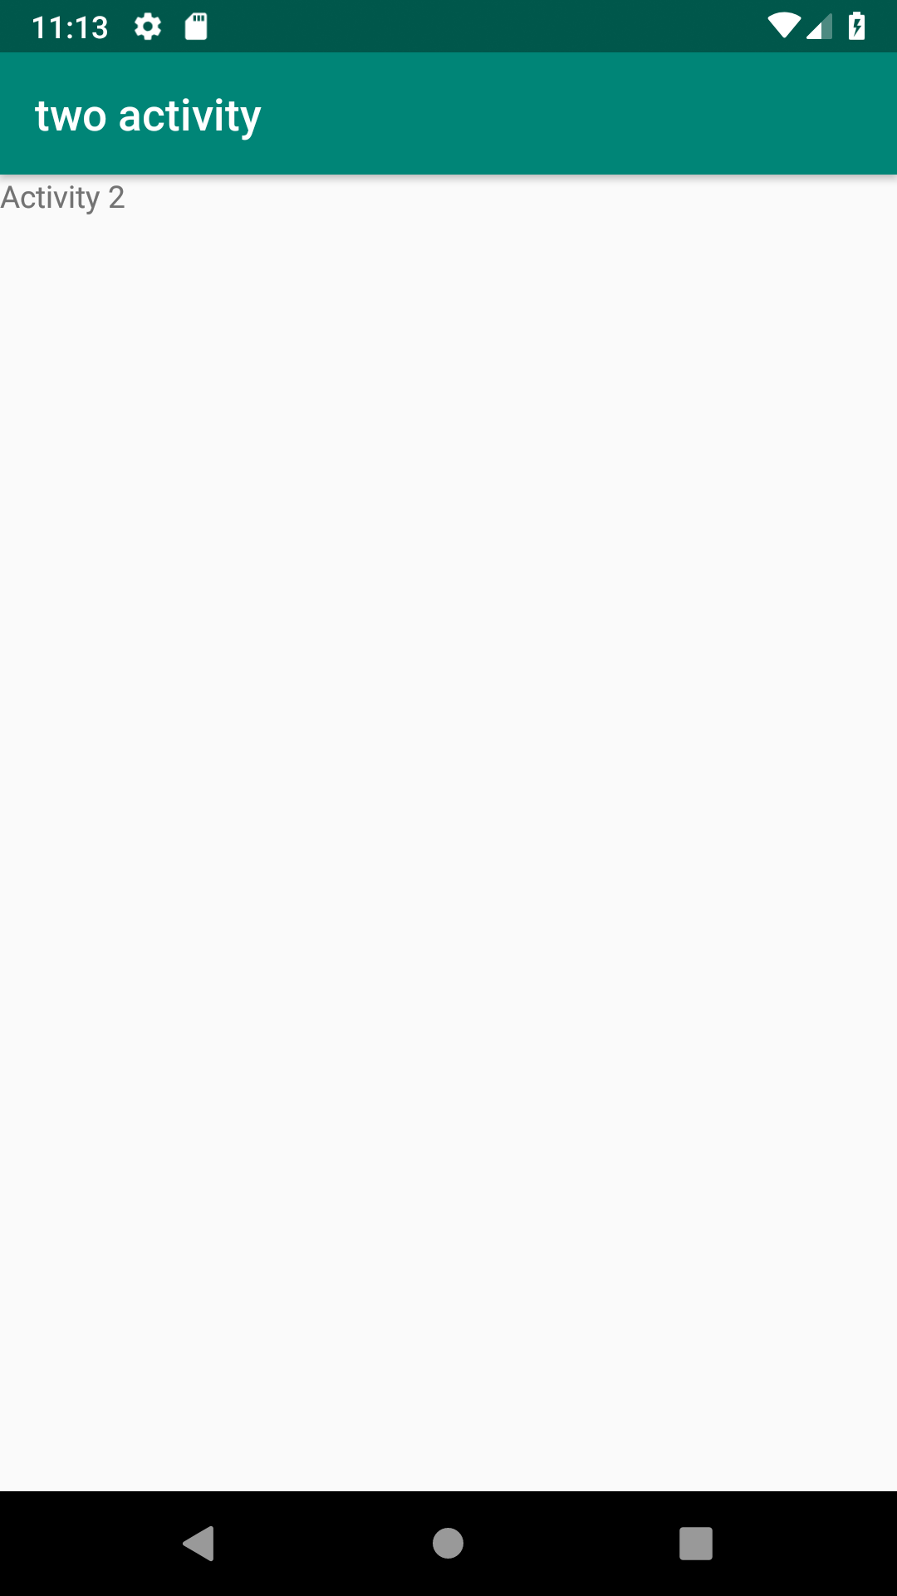

2.Create an Activity and move to facebook login page on a button click(making use of Intent).
activity-main.xml
package com.example.sjcet.facebook;
import android.content.Intent;
import android.net.Uri;
import android.support.v7.app.AppCompatActivity;
import android.os.Bundle;
import android.view.View;
import android.widget.Button;
public class MainActivity extends AppCompatActivity {
Button btn;
@Override
protected void onCreate(Bundle savedInstanceState) {
super.onCreate(savedInstanceState);
setContentView(R.layout.activity_main);
btn = findViewById(R.id.btn);
btn.setOnClickListener(new View.OnClickListener() {
@Override
public void onClick(View v) {
Intent intent = new Intent(Intent.ACTION_VIEW,Uri.parse("https://www.facebook.com/"));
startActivity(intent);
}
});
}
}

MainActivity.java
package com.example.sjcet.facebook;
import android.content.Intent;
import android.net.Uri;
import android.support.v7.app.AppCompatActivity;
import android.os.Bundle;
import android.view.View;
import android.widget.Button;
public class MainActivity extends AppCompatActivity {
Button btn;
@Override
protected void onCreate(Bundle savedInstanceState) {
super.onCreate(savedInstanceState);
setContentView(R.layout.activity_main);
btn = findViewById(R.id.btn);
btn.setOnClickListener(new View.OnClickListener() {
@Override
public void onClick(View v) {
Intent intent = new Intent(Intent.ACTION_VIEW,Uri.parse("https://www.facebook.com/"));
startActivity(intent);
}
});
}
}

OUTPUT

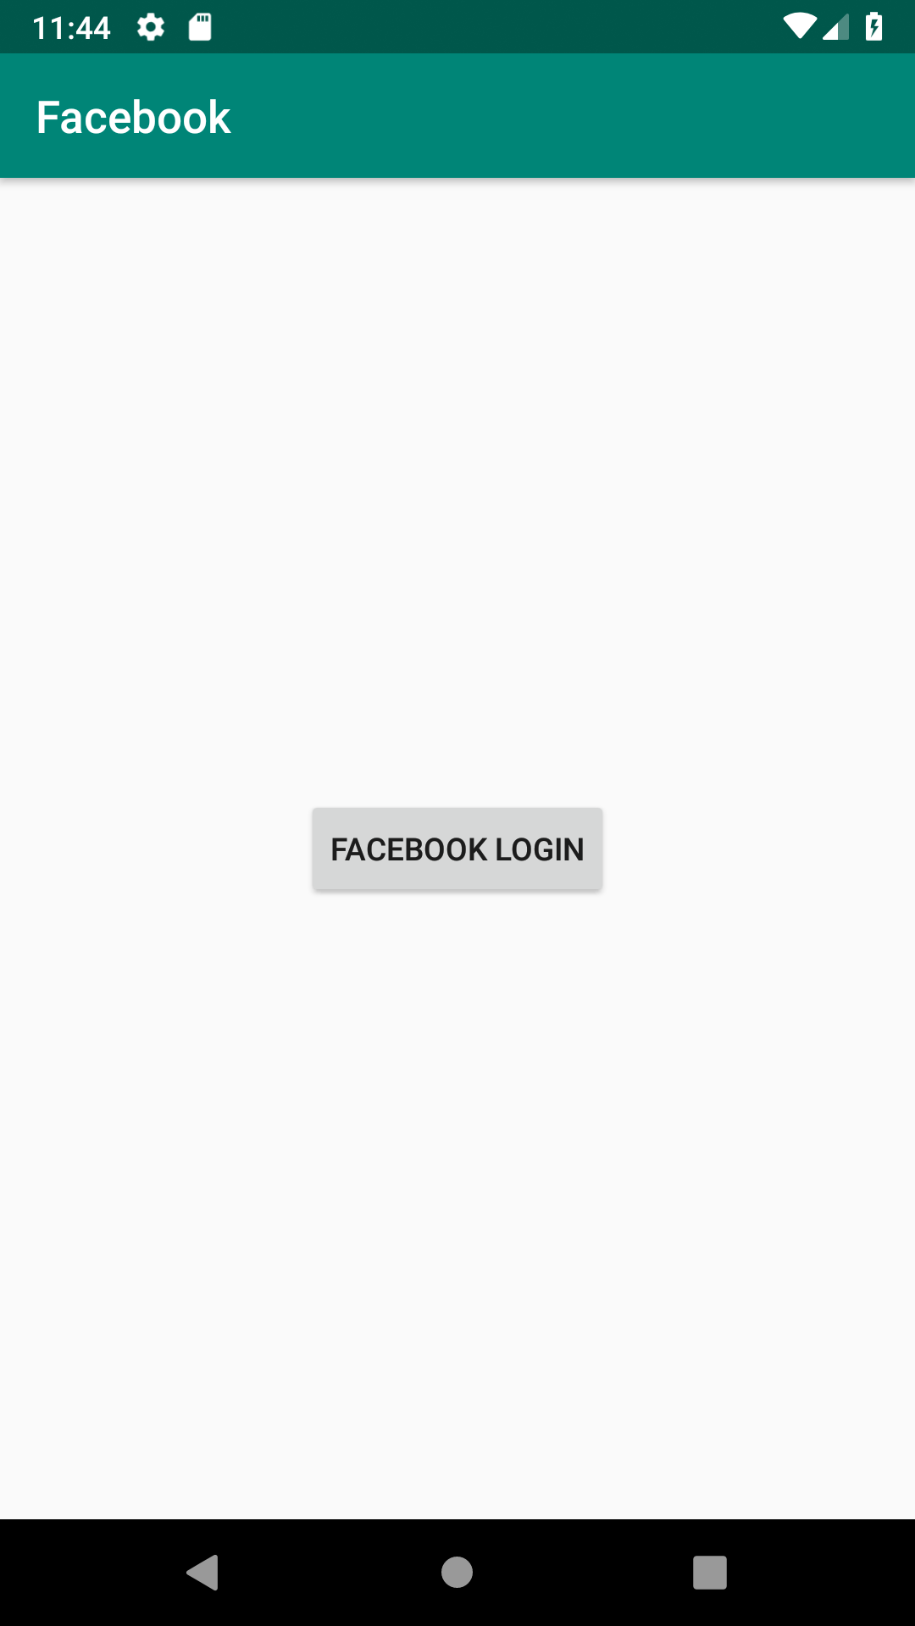

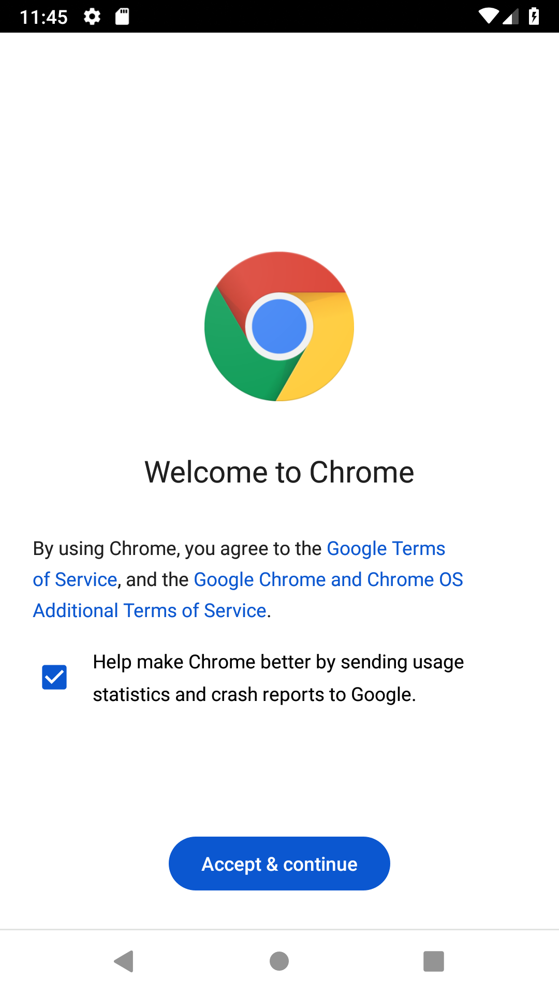

3.Read message from 1st Activity and pass it onto the 2nd Activity on a button click

activity_first_activity.xml
<?xml version="1.0" encoding="utf-8"?>
<RelativeLayout
xmlns:android="http://schemas.android.com/apk/res/android"
xmlns:app="http://schemas.android.com/apk/res-auto"
xmlns:tools="http://schemas.android.com/tools"
android:layout_width="match_parent"
android:layout_height="match_parent"
tools:context=".activity_first_activity">

<EditText
android:id="@+id/send_text_id"
android:layout_width="300dp"
android:layout_height="wrap_content"
android:textSize="25dp"
android:hint="Input"
android:textStyle="bold"
android:layout_marginTop="20dp"
android:layout_marginLeft="40dp"/>
<Button
android:id="@+id/send_button_id"
android:layout_width="wrap_content"
android:layout_height="40dp"
android:text="send"
android:textStyle="bold"
android:layout_marginTop="150dp"
android:layout_marginLeft="150dp"/>

</RelativeLayout>

activity_second_activity.xml

<?xml version="1.0" encoding="utf-8"?>
<?xml version="1.0" encoding="utf-8"?>
<RelativeLayout xmlns:android="http://schemas.android.com/apk/res/android"
xmlns:app="http://schemas.android.com/apk/res-auto"
xmlns:tools="http://schemas.android.com/tools"
android:layout_width="match_parent"
android:layout_height="match_parent"
tools:context="com.example.sjcet.msg.second_activity">

<TextView
android:id="@+id/received_value_id"
android:layout_width="300dp"
android:layout_height="50dp"
android:textStyle="bold"
android:textSize="40dp"
android:layout_marginTop="20dp"
android:layout_marginLeft="40dp"/>

</RelativeLayout>

activity_first_activity.java

package com.example.sjcet.msg;
import android.content.Intent;
import android.support.v7.app.AppCompatActivity;
import android.os.Bundle;
import android.view.View;
import android.widget.Button;
import android.widget.EditText;

public class activity_first_activity extends AppCompatActivity {

// define the variable
Button send_button;
EditText send_text;
@Override
protected void onCreate(Bundle savedInstanceState)
{
super.onCreate(savedInstanceState);
setContentView(R.layout.activity_first_activity);
send_button = (Button)findViewById(R.id.send_button_id);
send_text = (EditText)findViewById(R.id.send_text_id);

// add the OnClickListener in sender button
// after clicked this button following Instruction will run
send_button.setOnClickListener(new View.OnClickListener() {
@Override
public void onClick(View v)
{

// get the value which input by user in EditText
// and convert it to string
String str = send_text.getText().toString();

// Create the Intent object of this class Context() to Second_activity class
Intent intent = new Intent(getApplicationContext(),second_activity.class);

// now by putExtra method put the value in key, value pair
// key is message_key by this key we will receive the value, and put the string

intent.putExtra("message_key", str);

// start the Intent
startActivity(intent);
}
});
}
}

second_activity.java
package com.example.sjcet.msg;

import android.content.Intent;
import android.support.v7.app.AppCompatActivity;
import android.os.Bundle;
import android.widget.TextView;

public class second_activity extends AppCompatActivity {

TextView receiver_msg;
@Override
protected void onCreate(Bundle savedInstanceState)
{
super.onCreate(savedInstanceState);
setContentView(R.layout.activity_second_activity);

receiver_msg = (TextView)findViewById(R.id.received_value_id);

// create the get Intent object
Intent intent = getIntent();

// receive the value by getStringExtra() method
// and key must be same which is send by first activity
String str = intent.getStringExtra("message_key");

// display the string into textView
receiver_msg.setText(str);
}
}

